**Hurstville Private Hospital Healthe Care Surgical Pty Ltd HCF Case Payments**

1 February 2023

Amendment effective from 1 February 2024 to 31 January 2025

**Schedule C**



|  |  |  |  |
| --- | --- | --- | --- |
|  | | | |
|  |  |  |  |
|  |  |  |  |
|  |  |  |  |
|  |  |  |  |
|  |  |  |  |
|  |  |  |  |
|  |  |  |  |
|  |  |  |  |



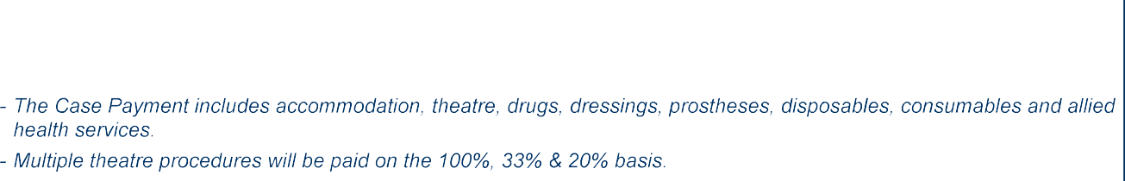

**COMMERCIAL IN CONFIDENCE Page 1 of 13**